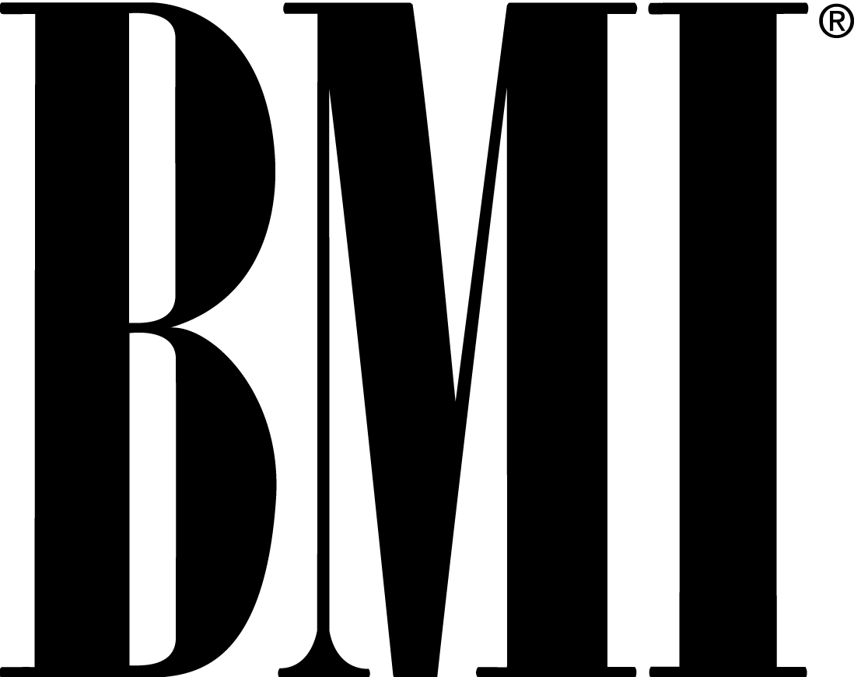

August 10, 2007

MEDIA ALERT

REV RUN OF RUN DMC, T.I., LIL JON, T-PAIN AND MORE EXPECTED AT BMI URBAN AWARDS IN LAS VEGAS ON SEPTEMBER 7

EVENT TO TAKE PLACE AT THE ZUMANITY THEATRE AT NEW YORK-NEW YORK HOTEL AND CASINO

WHAT: Friday, September 7, the 7th Annual BMI Urban Awards. An awards show presented by U.S. performing right organization BMI honoring the songwriters and publishers of the most performed urban songs on U.S. radio and television for the past 12 months. The awards will be hosted by Del R. Bryant, President & CEO of BMI, and Catherine Brewton, Vice President, Writer/Publisher Relations.

The Icon designation is given to BMI songwriters and artists who have had “a unique and indelible influence on generations of music makers.” Rev. Run will be saluted with an all-star musical tribute during the ceremony, and he joins an elite group that includes James Brown, Isaac Hayes, Al Green, Charlie Wilson and The Gap Band, Little Richard, Chuck Berry, and last year’s honorees, Antonio “L.A.” Reid and Kenny “Babyface” Edmonds.

As one third of Run-DMC, Rev Run helped change the sound of rap by simultaneously being more street and rock ‘n’ roll than his contemporaries with Run-DMC defining a new level of Black cool for the world. A multi-medium star – he stars in his own television show “Run’s House” as well working closely with brother Russell on the Phat Farm clothing line.

Also awarded will be the Urban Song of the Year, Songwriter of the Year, Producer of the Year and Publisher of the Year. BMI will also honor the Top Urban Producers of 2005-2006, as well as the BMI songwriters whose songs have hit No. 1 on the Billboard R&B, Hip-Hop and Rap charts. BMI will also present the Most Performed Urban Ringtone Award as well.

EXPECTED: Rev. Run of Run DMC, T.I., Rihanna, Kanye West, Ne-Yo, Jazze Pha, Lil Wayne, T-Pain, Yung Joc, Rich Boy, songwriter Sean Garrett (“Run It!,” “Soldier,” “Yeah!,” “Goodies”), DJ Unk (“Walk It Out”), Lloyd, Rodney Jerkins, Jason Pittman (“Party Like A Rockstar”), Lil Jon, E40, Shawty Put, DJ Ruckus and many more songwriters, music publishers and industry guests.

WHEN: Friday, September 7 – 5 p.m. press check-in, 6:00 p.m. arrivals. Red carpet ends at 8 p.m. This is a fashion-forward event; press are expected to dress appropriately.

WHERE: New York-New York Hotel and Casino, Zumanity Theatre, 3790 Las Vegas Blvd. South, Las Vegas, NV.

PRESS CREDENTIALS: All media must fill out a credentials request at press.bmi.com. Credentials close on Friday, August 31.

Credentials will be for red carpet arrivals only. A limited amount of working media, TV crews and still photographers on assignment will be allowed to cover the awards due to space. We will try to accommodate live shots for television with advance notice.

Handout video and high-resolution photos from the event will be available night of and at press.bmi.com.

ABOUT BMI:
Now celebrating more than 65 years in business, BMI is an American performing right organization that represents more than 300,000 songwriters, composers and publishers in all genres of music. With a repertoire of more than 6.5 million musical works from around the world, the non-profit-making corporation collects license fees from businesses that use music, which it then distributes as royalties to the musical creators and copyright owners it represents.

For more information and to get press credentials contact:
Hanna Pantle, BMI
310-289-6328; 310-497-5586 cell
HPantle@bmi.com

Patti Webster, W&W PR
732-469-5955; patti@w-wpr.com

