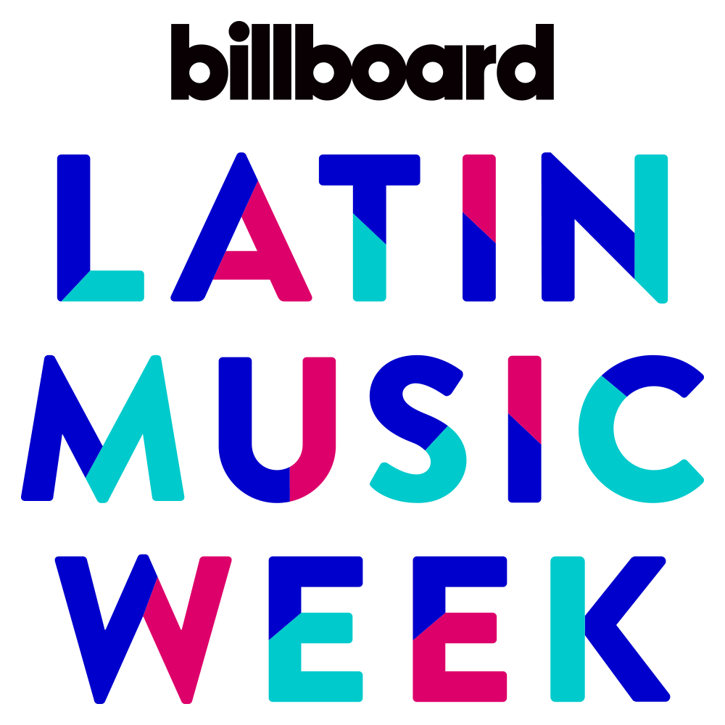BMI TO PRESENT popular series *HOW I WROTE THAT SONG®* AS PART OF THE billboard latin MUSIC WEEK in las vegas, APRIL 23-26

***Chart-topping Panelists Motiff, IAMCHINO, Jorge Gomez, Justin Quiles and Spiff TV Will Discuss Keys to Crafting a Hit Song***

**LOS ANGELES, CA – April 10, 2018 –** [**Broadcast Music, Inc.®, (BMI®)**](http://WWW.BMI.COM), the global leader in rights management, is proud to present its renowned ***How I Wrote That Song*®** at the Venetian Hotel in Las Vegas as part of the *Billboard* Latin Music week on **Tuesday, April 24, 2018**. *BMI’s How I Wrote That Song®* celebrates chart-topping singer-songwriters and producers, and serves as a platform for panelists to discuss the process of writing, producing and performing their hit songs. The informative and entertaining panel will be moderated by **BMI Vice President of Creative, Latin Music Delia Orjuela,** and will feature some of the industry’s most talented Latin music creators including **Motiff, IAMCHINO, Jorge Gomez, Justin Quiles** and **Spiff TV**.

“We are thrilled to add BMI’s ***How I Wrote That Song*®** panel to our incredible lineup for Billboard’s Latin Music Week,” said Leila Cobo, Executive Director, Latin Content and Programming at Billboard. “This year is going to be the biggest and best Latin Music Week yet with a robust list of panels and conversations including some of the most creative and talented artists in Latin music today. The stories behind the hits are endlessly fascinating and we look forward to hosting BMI and its writers!”

For more than ten years, *BMI’s* ***How I Wrote That Song®*** has provided an opportunity for aspiring songwriters, composers and producers to learn about the craft of songwriting and producing from today’s hottest music hitmakers. Previous Latin music participants include Horacio Palencia, Gocho, Benny Camacho, Roberto Tapia, Elvis Crespo, 24 Horas, El Dusty, Pinto “Wahin”, Juan Magan and Chino & Nacho.

The event will be part of *Billboard’s* Latin Music Week taking place April 23-26 in Las Vegas.***How I Wrote That Song*®** will be held in the Marcello Ballroom at the Venetian Hotel at 4:00 p.m. on Tuesday, April 24. To join the conversation, use hashtag #BMIHIWTS.

Media interested in attending should RSVP to the following link: <http://www.billboardevents.com/event/billboard-latin-music-week-2018/>

**About the panelists:**

[Motiff:](https://twitter.com/MotiffMusic) After arriving to Miami in 1996 and dedicating his time to the recording studio, Motiff gradually found himself working alongside the legendary Emilio and Gloria Estefan. Meeting Pitbull would also prove to be pivotal for Motiff. His career kicked into high gear as he found himself working with the who’s who of Latin music and earning an array of industry accolades, including a Latin GRAMMY® for Best Tropical Fusion Album in 2016 for his work on Gente De Zona’s *Visualízate*. The groundbreaking anthem he produced for that album, “La Gozadera,” landed him work alongside Marc Anthony, and has paved the way for further projects including Jennifer Lopez’s forthcoming release.

[IAMCHINO](http://iamchino.me/intro/)**:** His connection with Pitbull began when he was named as the official DJ for Mr. Worldwide. In addition to touring extensively with Pitbull and fulfilling his passion for DJ-ing, he took time to tap into his creative calling of producing. As a producer, he’s earned a GRAMMY ® award for his work on Pitbull’s *Dale* and a Latin GRAMMY® for his work on Gente De Zona’s *Visualízate.* IAMCHINO has also either penned or produced various hits for artist such as Enrique Iglesias, Ricky Martin, Yandel and Wisin, amongst others. His single “Ay Mi Dios,” which features Pitbull, Yandel and Chacal, has nearly 500 million views and has captured chart-topping success on *Billboard’s* Latin Airplay, Tropical Song and Latin Pop Song charts, amongst others.

Jorge Gomez**:** As a GRAMMY® award-winning composer and producer, he has experienced success for penning an array of hits including Pitbull’s *Climate Change, Dale & Armando* and Justine Quiles *La Promesa.* Additional chart-toppers have included“Don’t Stop the Party,” “Piensas Dile La Verdad,” “Ay Mi Dios,” and “El Taxi” to name a few.

[Justin Quiles](http://www.justinquiles.com/bio/)**:** Quiles is considered to be one of the most important figures of the new generation of Latin urban artists. His first studio album *The Promise* debuted in July 2016 and was #1 on *Billboard*'s Latin Rhythm Albums list. His hit "Si Ella Quisiera" remained atop *Billboard*’s Latin Airplay, Latin Pop Songs, Top Latin Albums, Hot Latin Songs and Tropical Songs charts. Quiles has also penned international hits for renowned artists such as Yandel, J Balvin and Maluma, and was the mastermind behind hits such as “Maria,” “Me Curare,” and “Orgullo” (Remix with J Balvin), which have all reached top positions on the *Billboard* Charts.  His most recent releases include "Pendiente de Usted," "Monstruo,” and "No Quiero Amarte" with Zion y Lennox.

[Spiff TV](https://www.instagram.com/spifftv/)**:** Known throughout the music industry as a mega influencer and “go-to-guy,” Spiff TV is greatly respected for his production, video direction and creative skills. Spiff has incorporated his innovative skills into his forthcoming release *The Union.* Top singles from the albumhave included the Bachata and R&B infused singles “Mi Combo - My Squad,” featuring Yandel and Future and “Just as I Am” featuring Chris Brown and Prince Royce, which was nominated for a Latin GRAMMY ® and reached top 10 on the *Billboard* Tropical Charts. In January 2018, *Billboard* Magazine named Spiff TV the number one Latin artist to watch in 2018.

**About Billboard:**

Billboard is the world's largest voice in music, built on the most complete and well-respected database of charts across all music genres. The Billboard charts define success in music. From the iconic Billboard magazine to Billboard.com, the ultimate consumer-facing destination for millions of passionate music fans, to the industry's most elite conference series and influencer events including the Power 100 and Women in Music – the Billboard brand has unmatched authority among fans, artists and the industry alike. Billboard has a social media footprint of 16.4 million social followers across Facebook, Twitter, Instagram, and YouTube, and creates more than 200M cross-platform video views per month. Billboard magazine has published major news-generating covers recently including Travis Scott, Zayn, Lorde, Marshmello, Demi Lovato, Cardi B, Selena Gomez, Eminem, DJ Khaled, Charlie Puth, and an open letter to Congress signed by 180+ of the music industry’s biggest stars and executives. In December 2017, the Billboard Women in Music ceremony, which honored Selena Gomez as Woman of the Year, was live-streamed globally on Twitter.

In 2016, The Hollywood Reporter-Billboard Media Group acquired SpinMedia’s storied music assets Spin, Vibe, and Stereogum, establishing the world’s largest music brand by digital traffic, social reach, and audience share. The combined entity of music and entertainment properties now reaches 47 million unique visitors and one in every three U.S. millennials.

**About BMI:**

Celebrating over 77 years of service to songwriters, composers, music publishers and businesses, Broadcast Music, Inc.® (BMI®) is a global leader in music rights management, serving as an advocate for the value of music. BMI represents the public performance rights in nearly 13 million musical works created and owned by more than 800,000 songwriters, composers, and music publishers. The Company negotiates music license agreements and distributes the fees it generates as royalties to its affiliated writers and publishers when their songs are performed in public. In 1939, BMI created a groundbreaking open-door policy becoming the only performing rights organization to welcome and represent the creators of blues, jazz, country, and American roots music. Today, the musical compositions in BMI’s repertoire, from chart toppers to perennial favorites, span all genres of music and are consistently among the most-performed hits of the year. For additional information and the latest BMI news, visit [bmi.com](https://t.e2ma.net/click/z4wncb/jkun5m/3b9wmk), follow us on Twitter [@BMI](https://t.e2ma.net/click/z4wncb/jkun5m/j49wmk) or stay connected through Broadcast Music, Inc.‘s [Facebook page](https://t.e2ma.net/click/z4wncb/jkun5m/zwaxmk). Sign up for [*BMI’s The Weekly*](https://t.e2ma.net/click/z4wncb/jkun5m/fpbxmk)™ and receive our e-newsletter every Monday to stay up to date on all things music.

**Media contact:**

Marlene Meraz, BMI / 310.289.6325 / [mmeraz@bmi.com](mailto:mmeraz@bmi.com)