

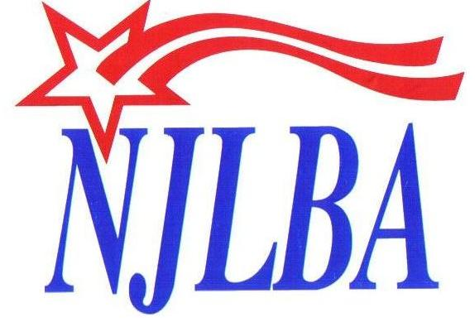
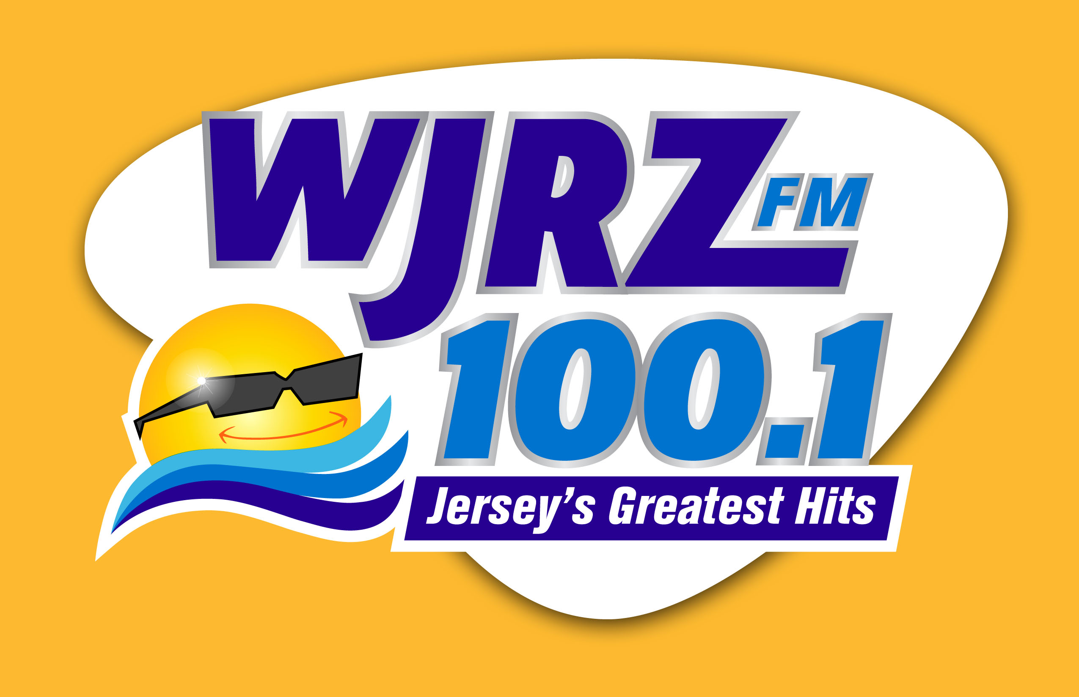
BMI GIVES BACK TO NEW JERSEY TAVERN
AFFECTED BY SUPERSTORM SANDY

BMI SONGWRITER CHRIS BARRON TO PERFORM AT NARDI’S
IN LONG BEACH ISLAND, NJ

NEW YORK, NY—May 21, 2013 – Broadcast Music, Inc.® (BMI®), the leading global music rights organization, has partnered with the New Jersey Licensed Beverage Association (NJLBA) to bring a New Jersey native, BMI songwriter and Spin Doctors front man, Chris Barron, to perform a benefit concert for Sandy Relief. Glenn Kalina of WJRZ-FM 100.1 Jersey’s Greatest Hits will be the Master of Ceremonies for the performance. Kalina has close ties to the community as he is a resident of Surf City, NJ. The event will take place at the rebuilt and BMI licensed, Nardi’s Tavern, in Long Beach Island, New Jersey, on Friday May 31, 2013, at 7:00 PM EST. A five-dollar donation will be requested upon entry to the event, which will go directly to Sandy Relief.

"As a Jersey native, my heart goes out to all the people who were and still are affected by Superstorm Sandy,” stated Chris Barron. He added, “I'm glad to have the opportunity to give a little back to the state that gave me so much."

“The Superstorm Sandy benefit at Nardi’s is a perfect example of how music is such an integral part of our society and continues to bring people together,” commented Michael Steinberg, Senior Vice President of Licensing at BMI. “It is a part of our tradition to support the community and establish lasting relationships. We are proud to sponsor BMI songwriter performances like this one with Chris Barron and to partner with the New Jersey Licensed Beverage Association.”

“For many of our licensees along the Jersey Shore, the past six months had been the most difficult time in their lives,” commented Diane Weiss, Executive Director of the New Jersey Licensed Beverage Association (NJLBA). Weiss explained, “Many of our members suffered great losses as a result of Superstorm Sandy. Both new licensees, and those that were landmarks in the industry for decades, were damaged or destroyed.” Weiss went on to say, “Since October, the NJLBA has been working closely with our members, as they restore their bars, taverns and restaurants. Today, through our partnership with BMI, we are proud to recognize the continuing efforts to rebuild the shore and to thank those individuals and organizations that have helped local businesses, such as Nardi’s, to ensure that they will again have a strong and prosperous future in New Jersey.”

The owner of Nardi’s Tavern, John Brennan, stated, “After experiencing firsthand how Superstorm Sandy affected all of our community, I’m grateful and proud to be able to reopen and sponsor this event with BMI to benefit other businesses and individuals still needing help.” Many communities hit by Superstorm Sandy have been focusing on renewed growth and positive beginnings. Nardi’s Tavern, a restaurant on the water in New Jersey, is well known for its lively music and performances. Affected by Superstorm Sandy in October 2012, the restaurant closed for four months in order to complete the rebuild.

Broadcast Music, Inc. ®(BMI) ® is a global leader in music rights management, serving as an advocate for the value of music. BMI represents the public performance rights in more than 7.5 million musical works created and owned by more than 600,000 songwriters, composers, and music publishers. The Company negotiates music license agreements and distributes the fees it generates as royalties to its affiliated writers and publishers when their songs are performed in public. In 1939, BMI created a groundbreaking open-door policy becoming the only performing rights organization to welcome and represent the creators of blues, jazz, country, and American roots music. Today, the musical compositions in BMI’s repertoire, from chart toppers to perennial favorites span all genres of music and are consistently among the most-performed hits of the year. For additional information and the latest BMI news, visit bmi.com, follow us on Twitter @BMI or stay connected through Broadcast Music Inc. (BMI) Facebook page.

The New Jersey Licensed Beverage Association (NJLBA) is a statewide trade organization representing on-premise licensees, educating and advising its membership as to proper and profitable trade practices. For more information please call 800-LBA-0076 or visit www.njlba.org.
###
Media Contact:
Leah Luddine, Broadcast Music, Inc. (BMI)
212-220-3142
lluddine@bmi.com

Diane M. Weiss, NJLBA
609-394-6730
DianeWeissnjlba@aol.com

