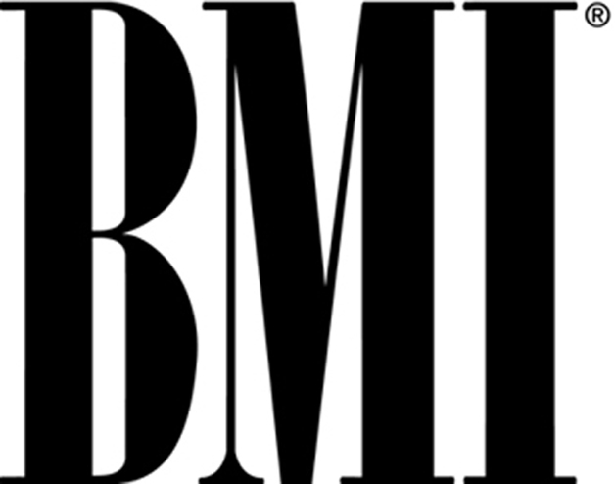

**BMI AT THE 2012 FRENCH QUARTER FESTIVAL**

**S A T U R D A Y , A P R I L 14**

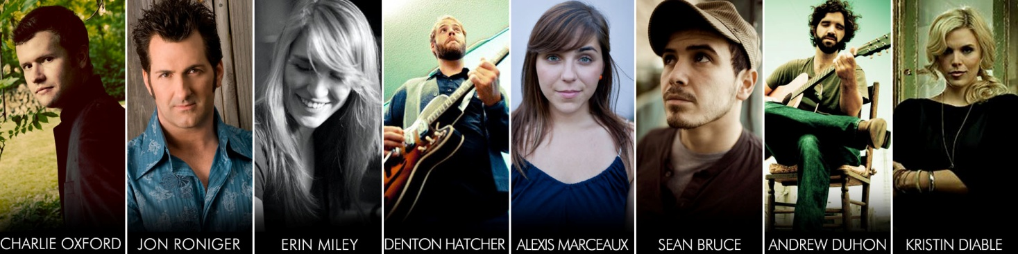

11-11:30am Charlie Oxford <http://charlieoxford.com/>

11:45-12:15am Jon Roniger <http://www.jonronigermusic.com/>

12:30-1:00pm Erin Miley <https://www.facebook.com/erin.miley>

1:15-1:45pm Denton Hatcher <http://dentonhatcher.com/>

2:00-2:30pm Alexis Marceaux <http://alexismarceaux.com/>

2:45-3:15pm Sean Bruce <https://www.facebook.com/SeanBruceFanPage>

3:30-4:00pm Andrew Duhon <http://andrewduhon.com/>

4:15-5:00pm Kristin Diable <http://www.kristindiable.com/>

**S U N D A Y , A P R I L 1 5**

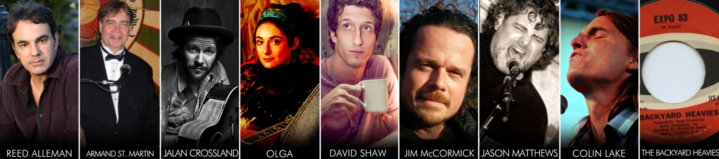

11-11:30am Reed Alleman <http://www.myspace.com/reedallemanmusic>

11:45-12:15am Armand St. Martin <http://www.myspace.com/armandstmartin>

12:30-1:00pm Jalan Crossland <http://www.jalancrossland.com/>

1:15-1:45pm Olga Wilhelmine <http://www.laolga.com/>

2:00-2:30pm David Shaw <http://www.therevivalists.com/>

2:45-3:15pm Jim McCormick & <http://www.myspace.com/jimmccormickmusic>

Jason Matthews <http://jasonmatthewsonline.com/>

3:30-4:00pm Colin Lake <http://colinlake.com/>

4:15-5:00pm The Backyard Heavies <http://youtu.be/EjQ70gCx0H4>

**WHAT:** The 2012 French Quarter Festival will highlight New Orleans' signature music, food, and culture April 12-16 in the event’s historic neighborhood namesake. The BMI songwriter stage returns for a third year and will feature 16 of the region's finest up-and-comers.

**WHEN:** Saturday, April 14 and Sunday, April 15 from 11 a.m. to 6 p.m.

**WHERE:**  The Historic New Orleans Collection

533 Royal Street, New Orleans, LA 70130

[www.hnoc.org](http://e2ma.net/go/2784035394/2517557/90738488/3825/b64/aHR0cDovL3d3dy5obm9jLm9yZw==)

**WHO:**  Singer/songwriters Charlie Oxford, Jon Roniger, Erin Miley, Denton Hatcher, Alexis Marceaux, Sean Bruce, Andrew Duhon, Kristin Diable, Reed Alleman, Armand St. Martin, Jalan Crossland, Olga Wilhemine, David Shaw, Jim McCormick & Jason Matthews, Colin Lake, and The Backyard Heavies.

**About the 2012 French Quarter Festival:**

Now in its 29th year, the largest free music festival in the South is proud to showcase the finest music, food and culture that are uniquely New Orleans. This year’s festival will feature over 275 hours of free music across 20 stages throughout the historic French Quarter. With over 800 local musicians, every genre is represented. From traditional and contemporary jazz, to rhythm and blues, New Orleans funk, Zydeco, to brass bands, folk, opera and gospel, there is truly something for everyone. Special events within the festival include the opening parade, the World Championship Crawfish Eating Contest, Battle of the Bands, Dancing at Dusk, the International Music Colloquium, family-fun activities at Children’s Headquarters, the World’s Largest Jazz Brunch, and more. The 2012 French Quarter Festival is produced by French Quarter Festivals, Inc., (FQFI) the 501(c)3 nonprofit Organization. For more information on French Quarter Festival, call 504-522-5730 or visit online at [www.fqfi.org](http://www.fqfi.org).

**About BMI:**

[Broadcast Music, Inc.](http://www.bmi.com/about)® (BMI®), a global leader in rights management, is an American performing rights organization that represents more than 500,000 songwriters, composers and music publishers in all genres of music and more than 7.5 million musical works. BMI has represented the most popular and beloved music from around the world for more than 70 years. The company provides licenses for businesses that perform music, and distributes the fees it generates as [royalties](http://www.bmi.com/about) to the musical creators and copyright owners it represents. Find out more at [www.bmi.com](http://www.bmi.com), follow [@BMI](http://twitter.com/BMI) on Twitter and stay connected through [Facebook](http://www.facebook.com/broadcastmusicinc).

**BMI media contact:**

Kay Clary

[kclary@bmi.com](mailto:kclary@bmi.com)

615-401-2728