




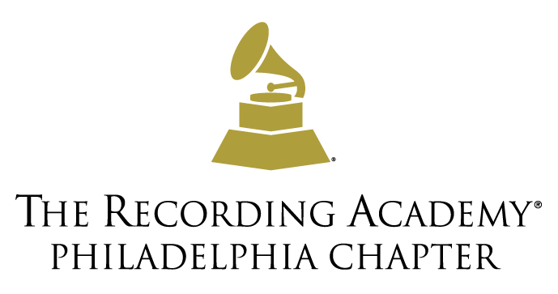

BMI TO HOST PANEL SERIES
‘HOW I WROTE THAT SONG’ IN PHILADELPHIA
NEW YORK – JUNE 4, 2013 – Broadcast Music, Inc.® (BMI)® is bringing its well-known "How I Wrote That Song®" panel series to the renowned Sigma Sound studio within the music mecca of Philadelphia. In collaboration with Radio One Philadelphia, The Recording Academy® Philadelphia Chapter and Philly360, BMI is providing an opportunity for aspiring songwriters and composers and those who are interested in learning about the craft of songwriting from legendary songwriters and today’s hitmakers. The panel series takes place on Saturday, June 8, 2013, from 1:30 – 6:30 p.m. Special appearances include BMI Board Member and Radio One Chairperson and Founder, Cathy Hughes; BMI Vice President, Writer/Publisher Relations, Atlanta, Catherine Brewton; and Recording Academy Philadelphia Chapter President, Ivan Barias. Tickets are $15 for general admission and are available for advanced purchase on the Old School 100.3 website.
Coinciding with Black Music Month, this panel series includes some of the industry’s most talented and accomplished music creators who began their careers in Philly. There will be two panel discussions: Generation Next Panel, moderated by DJ Damage of Hot 107.9, and Legends Songwriting Panel, moderated by Dyana Williams, on air-personality for Old School 100.3 Radio One Philadelphia. Panel participants include Andrew “Pop” Wansel, BMI’s Producer of the Year; GRAMMY®-nominated producer, Warren “Oak” Felder; The Phatboiz, producers of GRAMMY-nominated tracks; Kenny Gamble and Leon Huff, both Rock and Roll Hall of Famers and GRAMMY-winning songwriters; and James Mtume, GRAMMY-winning songwriter, musician and producer. Dunson will perform two songs between panels.

Music producer Warren “Oak” Felder commented, “Pop and I are excited to discuss our songwriting process with music legends such as Gamble and Huff, and up-and-comers such as The Phatboiz." Dan Spears, Vice President of Industry Relations, Licensing at BMI stated, “BMI is proud to collaborate with Radio One and The Recording Academy and continue the music education theme that we have created with our well-known panel series, ‘How I Wrote That Song.’” Spears continued, “Bringing our event to the Philadelphia region, where some of the industry’s most renowned songwriters started their careers, is something BMI is thrilled to do.”

Ivan Barias, President of The Recording Academy Philadelphia Chapter commented, “Great time to be a music maker in Philly. Watching two generations of hitmakers discussing their craft is something to be excited about.” Meryl Levitz, President and CEO, Greater Philadelphia Tourism Marketing Corporation (GPTMC), stated, “We are happy to partner with BMI for the ‘How I Wrote That Song’ event.” Levitz explained, “GPTMC’s Philly 360° campaign builds buzz about Philly’s creative scene, and this event showcases what we love to spotlight everyday—our local songwriters, producers and radio personalities. And we’re in great company with our partners on this event—BMI, Hot 107.9, Old School 100.3, and Sigma Sound .”

Broadcast Music, Inc.® (BMI®) is a global leader in music rights management, serving as an advocate for the value of music. BMI represents the public performance rights in more than 7.5 million musical works created and owned by more than 600,000 songwriters, composers, and music publishers. The Company negotiates music license agreements and distributes the fees it generates as royalties to its affiliated writers and publishers when their songs are performed in public. In 1939, BMI created a groundbreaking open-door policy becoming the only performing rights organization to welcome and represent the creators of blues, jazz, country, and American roots music. Today, the musical compositions in BMI’s repertoire, from chart toppers to perennial favorites span all genres of music and are consistently among the most-performed hits of the year. For additional information and the latest BMI news, visit bmi.com, follow us on Twitter @BMI or stay connected through Broadcast Music Inc. (BMI) Facebook page.

Radio One, Inc. is a diversified media company that primarily targets African-American and urban consumers. The Company is one of the nation's largest radio broadcasting companies, currently owning 53 broadcast stations located in 16 urban markets in the United States. As a part of its core broadcasting business, Radio One operates syndicated programming including the Russ Parr Morning Show, the Yolanda Adams Morning Show, the Rickey Smiley Morning Show, Bishop T.D. Jakes' "Empowering Moments," the Reverend Al Sharpton Show and the Warren Ballentine Show. The Company also owns a controlling interest in Reach Media, Inc. (http://www.blackamericaweb.com/) and owns the Tom Joyner Morning Show and other businesses associated with Tom Joyner. Beyond its core radio broadcasting business, Radio One owns Interactive One (http://www.interactiveone.com/), an online platform serving the African-American community through social content, news, information and entertainment, which operates a number of branded sites, including News One, UrbanDaily, HelloBeautiful, Community Connect Inc. (http://www.communityconnect.com/), an online social networking company, which operates a number of branded websites, including BlackPlanet, MiGente, and Asian Avenue and an interest in TV One, LLC (http://www.tvoneonline.com/), a cable/satellite network programming primarily to African-Americans.

Established in 1957, The Recording Academy is an organization of musicians, songwriters, producers, engineers and recording professionals that is dedicated to improving the cultural condition and quality of life for music and its makers. Internationally known for the GRAMMY Awards — the preeminent peer-recognized award for musical excellence and the most credible brand in music — The Recording Academy is responsible for groundbreaking professional development, cultural enrichment, advocacy, education and human services programs. The Academy continues to focus on its mission of recognizing musical excellence, advocating for the well-being of music makers and ensuring music remains an indelible part of our culture. For more information about The Academy, please visit www.grammy.com. For breaking news and exclusive content, follow @TheGRAMMYs on Twitter, like "The GRAMMYs" on Facebook, and join The GRAMMYs' social communities on Foursquare, GetGlue, Google +, Instagram, Pinterest, Tumblr, and YouTube.

Philly 360°®, Greater Philadelphia Tourism Marketing Corporation’s (GPTMC) newest initiative for the African American market spotlights trendsetters—musicians, visual artists, dancers, poets, designers, producers and more—who are in touch with what’s cool, hip and hot in the city and region. These Creative Ambassadors use their social networks to build buzz about Philly as a travel hotspot and encourage a younger, tech-savvy crowd to visit. Our lead Creative Ambassadors include GRAMMY-winning hip-hop group The Roots in 2009, GRAMMY-winning singer/songwriter Marsha Ambrosius in 2010, DJ and GRAMMY-winning producer DJ Jazzy Jeff and GRAMMY-nominated songwriters/producers Carvin & Ivan in 2011 and Eagles Cornerback Nnamdi Asomugha and GRAMMY-winning producers Andre Harris and Vidal Davis in 2012.
Media Contacts:
Leah Luddine, Broadcast Music, Inc. (BMI)
212-220-3142
lluddine@bmi.com

Amir Khan, Radio One, Inc.
610-538-1101
akhan@radio-one.com

Lourdes L. Patton, The Recording Academy
310.392.3777
lourdesl@grammy.com

