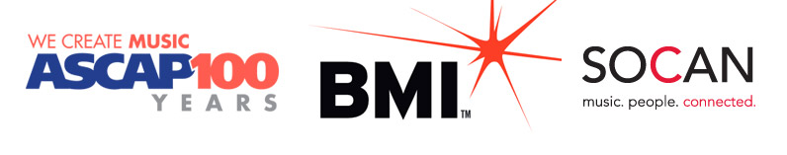

**ASCAP, BMI and SOCAN Collaborate on MusicMark**

To meet the needs of today’s changing marketplace, ASCAP, BMI and SOCAN have collaborated to create [MusicMark](http://www.musicmark.com). The new initiative is designed to simplify the music registration process, and create a synchronized picture of the music of the songwriters, composers and music publishers that each performing rights organization (PRO) represents.

ASCAP, BMI and SOCAN together issued the following statement about MusicMark:

"ASCAP, BMI and SOCAN launched MusicMark to give our members a more efficient way to register their music. As of March 31st, 2014, publishers that use Common Works Registration (CWR) can submit registration files to all three organizations simultaneously via MusicMark, even if the work was co-written by members of different societies. Each PRO will then integrate the data into its repertory of works.

"We remain three distinct organizations, and anyone who uses MusicMark will continue to receive royalty distributions from each PRO individually. But we are united in our commitment to making the registration process more convenient for all of our respective members. We look forward to sharing more details about MusicMark in the coming months."

For more about MusicMark and how it works, please visit musicmark.com.