**FOR IMMEDIATE RELEASE**

**BUSTA RHYMES HONORED AS BMI ICON AT THE   
2022 BMI R&B/HIP-HOP AWARDS**

***“Peaches” Named BMI R&B/Hip-Hop Song of the Year;  
Megan Thee Stallion and Christopher “YC” Pearson Tied for Songwriter of the Year;  
D’Mile Presented with Producer of the Year;  
Sony Music Publishing Honored as Publisher of the Year***

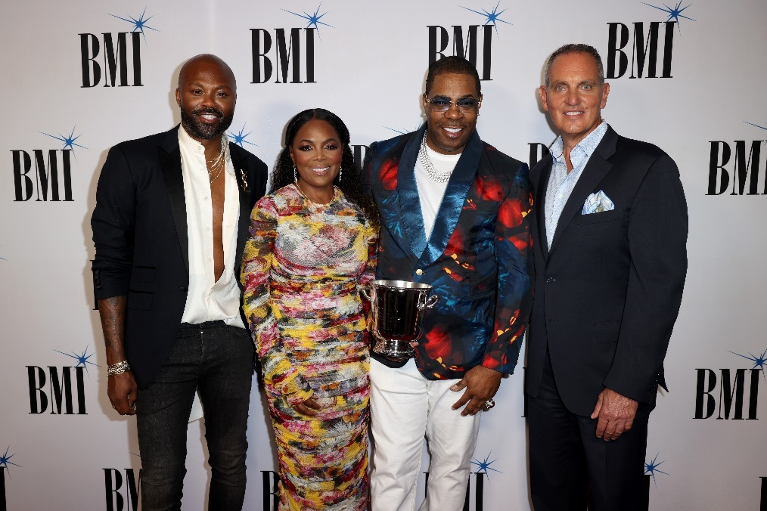

BMI's Wardell Malloy and Catherine Brewton pose with BMI Icon Busta Rhymes and BMI President & CEO Mike O'Neill at the 2022 BMI R&B/Hip-Hop Awards at LIV Nightclub Miami Beach on September 7.   
Photo Credit- Alexander Tamargo/Getty Images for BMI.

**(Miami, FL- September 8, 2022)** [**BMI (Broadcast Music, Inc.)**](http://www.bmi.com/) paid tribute to the best in R&B and Hip-Hop last night at its **2022 R&B/Hip-Hop Awards** held at **LIV Nightclub Miami Beach**. **Busta Rhymes** was honored as the **BMI Icon** for the indelible and unique influence that he has had on the music industry and on generations of music creators. In addition, BMI’s **R&B/Hip-Hop Producer of the Year**, **Song of the Year**, **Songwriter of the Year**, **Publisher of the Year** and BMI’s **top 35 most-performed pop songs** in the U.S. of the previous year were also announced. The private event was hosted by **BMI President & CEO Mike O’Neill** and **BMI Vice President, Creative (Atlanta) Catherine Brewton**.

**DJ Khaled** welcomed the crowd and kicked off the celebration, while **DJ Nasty** kept everyone on their feet with sets throughout the evening. The music continued with soul trap singer and rapper **Morray** performing his hit songs, “Bad Situations” and “Quicksand,” and Nigerian singer/songwriter and producer **Pheelz** performing “Electricity” and his viral hit, “Finesse.”

During the celebration, BMI recognized the top producers and songwriters of the previous year’s 35 best-performing R&B/Hip-Hop songs in the U.S., leading up to the prestigious **Song of the Year**, which went to **“Peaches**,**”** written by **Daniel Caesar**, **GIVĒON**, **Bernard “HARV” Harvey**, **Luis Manuel Martinez Jr.** **(Shndō)** and **Andrew Watt**. The song entered Billboard’s Hot 100 Chart at number one and has been certified triple platinum by the RIAA.

**D’Mile** was presented with **Producer of the Year** for his work on “Fair Trade” by Drake and Travis Scott, and “Smokin Out The Window,” “Skate” and “Leave The Door Open” by Silk Sonic. Hitmakers **Megan Thee Stallion** and **Christopher “YC” Pearson** tied as **Songwriter of the Year** for each writing three of the most performed songs. Megan Thee Stallion was honored for “Body,” “Cry Baby” and “Thot Shit” and YC for his work on “Back in Blood,” “Time Today” and “Wockesha.”

**Sony Music Publishing** received **BMI’s R&B/Hip-Hop Publisher of the Year** for representing 20 of the previous year’s most performed songs including BMI’s R&B/Hip-Hop Song of the Year, “Peaches,” as well as “Lemonade,” “Rapstar” and “Way 2 Sexy,” to name a few.

The evening closed with O’Neill introducing **Busta Rhymes** as the BMI Icon for his “defining impact on hip-hop and for mentoring the next generation of talent.” Before accepting his award, a video tribute was shown with some of Rhymes’ famous peers including Janet Jackson, Lil Wayne, Missy Elliot, Fat Joe and Mariah Carey sharing the love and respect they had for the iconic entertainer. Pharrell Williams was then called to the stage where he reminisced about his longstanding relationship with Rhymes noting that he felt “honored to be in the presence of someone who had the courage to be so different… and still does today.”

On receiving the evening’s highest honor, Rhymes commented, “We’re all blessed with this gift. It’s one thing to identify with the gift, it’s another thing to believe in it once you identify with it.” He went on to say, “The most beautiful part about it is I earned this… I’ve never been celebrated as an icon before, but I never had to question whether I was one.” Rhymes then performed a melody of some of his biggest hits such as “Break Ya Neck,” “Scenario”, and “Put Your Hands Where My Eyes Could See” with longtime friend and collaborator Spliff Star and DJ Scratchator. Pharrell closed the night by joining Rhymes onstage for an explosive performance of “Pass the Courvoisier.”

As the 2022 BMI Icon, Busta Rhymes joins an elite group of music creators who have received BMI’s highest honor. Previous recipients include Janet Jackson, Patti LaBelle, Nile Rodgers, Snoop Dogg, The Jacksons, LA Reid, Babyface, Al Green, Isaac Hayes, James Brown and more.

To see a complete list of winners, please visit <https://www.bmi.com/award-shows/r-and-b-hip-hop-2022/>and use hashtag **#BMIRnBHHAwards** on social. For, high res photos and video clips from the event go to [https://publicity.gettyimages.com/event/2022-bmi-r-b-hip-hop-awards](https://nam02.safelinks.protection.outlook.com/?url=https%3A%2F%2Fpublicity.gettyimages.com%2Fevent%2F2022-bmi-r-b-hip-hop-awards&data=05%7C01%7Cjthomas%40bmi.com%7Cae5d9dab95964d69fcda08da8b95e383%7C3bbeab8167a442cca0685dcb39061843%7C1%7C0%7C637975773160522984%7CUnknown%7CTWFpbGZsb3d8eyJWIjoiMC4wLjAwMDAiLCJQIjoiV2luMzIiLCJBTiI6Ik1haWwiLCJXVCI6Mn0%3D%7C3000%7C%7C%7C&sdata=piIdIdSZ9uJhidTf5VIctJOI9m4WHPnFyP%2F0FGSd6iQ%3D&reserved=0).

**ABOUT BMI:**

Celebrating over 80 years of service to songwriters, composers, music publishers and businesses, Broadcast Music, Inc.® (BMI®) is a global leader in music rights management, serving as an advocate for the value of music. BMI represents the public performance rights in over 18.7 million musical works created and owned by more than 1.2 million songwriters, composers, and music publishers. The Company negotiates music license agreements and distributes the fees it generates as royalties to its affiliated writers and publishers when their songs are performed in public. In 1939, BMI created a groundbreaking open-door policy becoming the only performing rights organization to welcome and represent the creators of blues, jazz, country, and American roots music. Today, the musical compositions in BMI’s repertoire, from chart toppers to perennial favorites, span all genres of music and are consistently among the most-performed hits of the year. For additional information and the latest BMI news, visit [bmi.com](https://nam02.safelinks.protection.outlook.com/?url=https%3A%2F%2Ft.e2ma.net%2Fclick%2F7m0ocd%2Fflkdio%2Fj8w9uv&data=02%7C01%7Cjthomas%40bmi.com%7C636d38f653f24ffb355108d757c9c7cf%7C3bbeab8167a442cca0685dcb39061843%7C1%7C0%7C637074396482316066&sdata=DPBSfR42rUy8asIawoS6%2FpGoQjQ0gjb8RpV%2F4OwK9h4%3D&reserved=0), follow us on [Twitter](https://twitter.com/bmi) and [Instagram](https://www.instagram.com/bmi/) @BMI or stay connected through Broadcast Music, Inc.’s [Facebook](https://nam02.safelinks.protection.outlook.com/?url=https%3A%2F%2Ft.e2ma.net%2Fclick%2F7m0ocd%2Fflkdio%2Ffty9uv&data=02%7C01%7Cjthomas%40bmi.com%7C636d38f653f24ffb355108d757c9c7cf%7C3bbeab8167a442cca0685dcb39061843%7C1%7C0%7C637074396482326060&sdata=XLFpwfKVAAyV5pLiRXEDgjcWzpJvUx4mItDdMGiMPKY%3D&reserved=0) page. Sign up for BMI’s [*The Weekly*](https://nam02.safelinks.protection.outlook.com/?url=https%3A%2F%2Ft.e2ma.net%2Fclick%2F7m0ocd%2Fflkdio%2Fvlz9uv&data=02%7C01%7Cjthomas%40bmi.com%7C636d38f653f24ffb355108d757c9c7cf%7C3bbeab8167a442cca0685dcb39061843%7C1%7C0%7C637074396482336056&sdata=4OjEOc8zwmabrq9evho6h4XM15wUK0ib3Rerq4sWjdQ%3D&reserved=0)™ and receive our e-newsletter every week to stay up to date on all things music.

**Media Contacts:**  
Gabriella Natali                              Jodie Thomas  
212.220.3141                                 212.220.3142  
[gnatali@bmi.com](mailto:gnatali@bmi.com)                         [jthomas@bmi.com](mailto:jthomas@bmi.com)