**FOR IMMEDIATE RELEASE**

**BUSTA RHYMES TO BE HONORED AS A BMI ICON AT THE   
2022 BMI R&B/HIP-HOP AWARDS**

***Evening Also Celebrates the Top R&B/Hip-Hop Songwriters, Producers and Music Publishers on Wednesday, September 7 in Miami, FL***

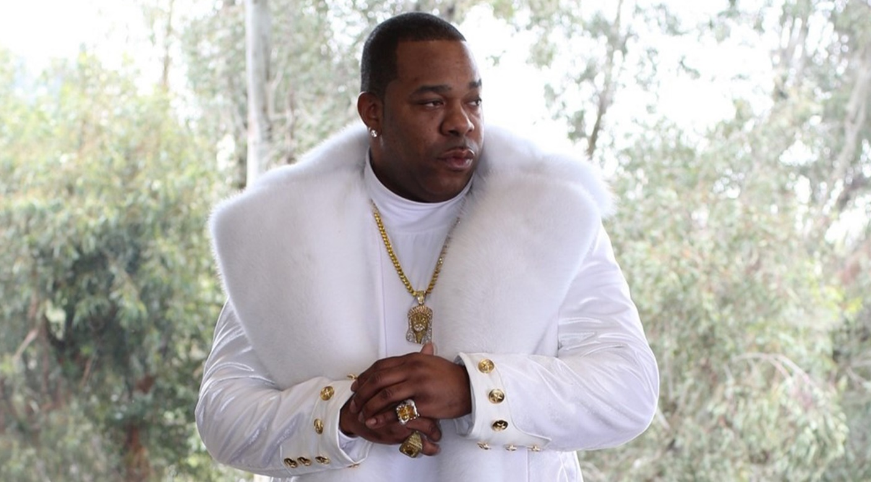

BUSTA RHYMES- Photo Credit: Joseph "Jo Lenz" Kindred

**(New York, NY- August 9, 2022)** [**BMI (Broadcast Music, Inc.)**](http://www.bmi.com/) will honor the multiple award-winning songwriter/rapper/producer and actor **Busta Rhymes** with the **BMI Icon Award** at its **2022 R&B/Hip-Hop Awards** on **September 7**. The private event, held at the **LIV** **Nightclub Miami Beach**, will be hosted by **BMI President & CEO Mike O’Neill** and **BMI Vice President, Creative (Atlanta) Catherine Brewton**.

“As one of the pioneers of hip-hop, we are excited to honor Busta Rhymes as a BMI Icon,” said **Brewton**. “Through his award-winning solo work, countless collaborations and acting, Busta is a true innovator in every sense of the word and has made a dynamic impact on legions of fans and music creators worldwide. His quick wit and intricate rapping style have made him legendary, inspiring many young performers to follow in his footsteps. We’re also thrilled to be back in person in Miami, celebrating our top music creators behind some of today’s most-performed songs. We’re looking forward to a fantastic night of great music.”

Throughout the evening, BMI will also salute the songwriters, producers and music publishers of the past year’s 35 most-performed R&B/Hip-Hop songs in the United States from BMI’s repertoire of more than 18.7 million musical works. The BMI R&B/Hip-Hop Songwriter, Producer and Publisher of the Year will also be named during the ceremony.

Rhymes launched his musical career in the early 90s with the hip-hop crew Leaders of the New School. He moved on to become an in-demand collaborator, appearing on numerous tracks for other artists before he officially went solo in 1996 with his massive hit, “Woo-Hah!! Got You All in Check.” The single was quickly certified platinum, earning him his first GRAMMY nomination. Throughout the ’90s and 2000s, he was a creative force, topping the charts, including debuting at number one in 2006 with his seventh studio album, The Big Bang. Several of his hit songs, such as “Put Your Hands Where My Eyes Can See,” “Break Ya Neck,” “Dangerous,” “Gimme Some More” and “What’s It’s Gonna Be?,” featuring Janet Jackson, became hip-hop anthems, solidifying his place as one of the most in-demand rappers in the industry. In 2020, he independently released the critically acclaimed ELE 2: The Wrath of God, with NME saying it was “arguably one of the best-produced hip-hop albums of the last five years.”

Throughout his career spanning over three decades, Rhymes has received numerous accolades and awards, including six BET Awards, eight BMI Awards, a Billboard R&B/Hip-Hop Award, a Soul Train Award, as well as 12 GRAMMY and 16 MTV Video Music Award nominations.

Beyond his work in music, Rhymes has appeared in several films and television series, including in Shaft, Finding Forrester, Master of None, The Rugrats Movie, and he competed in The Masked Singer on FOX.

The BMI Icon Award is presented to songwriters, composers or producers who have distinctly and profoundly influenced the music industry, leaving an indelible and unique influence on generations of music makers. As the 2022 honoree, Busta Rhymes joins an elite group of music creators who have received BMI’s highest honor. Previous recipients include Janet Jackson, Patti LaBelle, Nile Rodgers, Snoop Dogg, The Jacksons, LA Reid, Babyface, Al Green, Isaac Hayes, James Brown and more.

For more information on the BMI R&B/Hip-Hop Awards, visit <https://www.bmi.com/genres/rb_hiphop> and use hashtag **#BMIRnBHHAwards** on social.

Press credentials will be for red-carpet arrivals only and will be very limited due to capacity. To apply for credentials, please go to <https://www.bmi.com/press/credential/2022-bmi-rb-hip-hop-awards>.

A post event press release, photos and video will be serviced after the event.

**ABOUT BMI:**

Celebrating over 80 years of service to songwriters, composers, music publishers and businesses, Broadcast Music, Inc.® (BMI®) is a global leader in music rights management, serving as an advocate for the value of music. BMI represents the public performance rights in over 18.7 million musical works created and owned by more than 1.2 million songwriters, composers, and music publishers. The Company negotiates music license agreements and distributes the fees it generates as royalties to its affiliated writers and publishers when their songs are performed in public. In 1939, BMI created a groundbreaking open-door policy becoming the only performing rights organization to welcome and represent the creators of blues, jazz, country, and American roots music. Today, the musical compositions in BMI’s repertoire, from chart toppers to perennial favorites, span all genres of music and are consistently among the most-performed hits of the year. For additional information and the latest BMI news, visit [bmi.com](https://nam02.safelinks.protection.outlook.com/?url=https%3A%2F%2Ft.e2ma.net%2Fclick%2F7m0ocd%2Fflkdio%2Fj8w9uv&data=02%7C01%7Cjthomas%40bmi.com%7C636d38f653f24ffb355108d757c9c7cf%7C3bbeab8167a442cca0685dcb39061843%7C1%7C0%7C637074396482316066&sdata=DPBSfR42rUy8asIawoS6%2FpGoQjQ0gjb8RpV%2F4OwK9h4%3D&reserved=0), follow us on [Twitter](https://twitter.com/bmi) and [Instagram](https://www.instagram.com/bmi/) @BMI or stay connected through Broadcast Music, Inc.’s [Facebook](https://nam02.safelinks.protection.outlook.com/?url=https%3A%2F%2Ft.e2ma.net%2Fclick%2F7m0ocd%2Fflkdio%2Ffty9uv&data=02%7C01%7Cjthomas%40bmi.com%7C636d38f653f24ffb355108d757c9c7cf%7C3bbeab8167a442cca0685dcb39061843%7C1%7C0%7C637074396482326060&sdata=XLFpwfKVAAyV5pLiRXEDgjcWzpJvUx4mItDdMGiMPKY%3D&reserved=0) page. Sign up for BMI’s [*The Weekly*](https://nam02.safelinks.protection.outlook.com/?url=https%3A%2F%2Ft.e2ma.net%2Fclick%2F7m0ocd%2Fflkdio%2Fvlz9uv&data=02%7C01%7Cjthomas%40bmi.com%7C636d38f653f24ffb355108d757c9c7cf%7C3bbeab8167a442cca0685dcb39061843%7C1%7C0%7C637074396482336056&sdata=4OjEOc8zwmabrq9evho6h4XM15wUK0ib3Rerq4sWjdQ%3D&reserved=0)™ and receive our e-newsletter every week to stay up to date on all things music.

**Media Contacts:**  
Gabriella Natali                              Jodie Thomas  
212.220.3141                                 212.220.3142  
[gnatali@bmi.com](mailto:gnatali@bmi.com)                         [jthomas@bmi.com](mailto:jthomas@bmi.com)